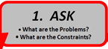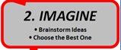  What is your problem?  What are the constraints? | 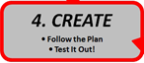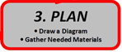  Draw a diagram of your geodesic dome:  What shape will you repeat to make your geodesic dome?  Materials:  >  >  >
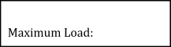
How would you improve your geodesic dome?

